ORDINANCE NO. 2023-002

AN ORDINANCE OF THE TOWN OF PEMBROKE PARK, FLORIDA, AMENDING CHAPTER 28, ENTITLED “ZONING;” CREATING DIVISION 5.8, TO BE ENTITLED “MXE - MIXED-USE ENTERTAINMENT DISTRICT;” PROVIDING REGULATIONS FOR THE MIXED-USE ENTERTAINMENT DISTRICT; PROVIDING FOR DEFINITIONS; PROVIDING FOR INTENT AND PURPOSE; PROVIDING FOR PERMITTED USES AND SPECIFIC USE REGULATIONS; PROVIDING FOR HEIGHT RESTRICTIONS; PROVIDING FOR FLOOR AREA REGULATIONS; PROVIDING FOR SETBACKS; PROVIDING FOR PARKING; PROVIDING FOR A GEOGRAPHIC AREA; PROVIDING FOR DEVELOPMENT STANDARDS; PROVIDING FOR CODIFICATION; PROVIDING FOR CONFLICTS; PROVIDING FOR SEVERABILITY; AND PROVIDING FOR AN EFFECTIVE DATE.

WHEREAS, Article VIII, Section 2, Florida Constitution, grants municipalities the power to conduct municipal government, perform municipal functions, and render municipal services; and
WHEREAS, the Town Commission seeks to establish a mixed-use entertainment district in the Town; and
WHEREAS, the Town’s Planning and Zoning Board recommended approval of this ordinance at its January 5, 2023 meeting; and
WHEREAS, the general purpose and intent of this ordinance is to provide proper zoning regulations in the best interest of the health, safety, welfare, and aesthetics of the community and the proper administration of its government; and
WHEREAS, the specific purpose and intent of this ordinance is to create a mixed-use entertainment district to revitalize an underutilized corridor by providing commercial, restaurant, various entertainment, hotel, office, and residential uses; and
WHEREAS, the Town Commission has conducted a public hearing in accordance with the requirements of Florida law; and
WHEREAS, the Town Commission finds it to be in the best interests of the citizens and residents of the Town to establish a mixed-use entertainment district in the Town to provide for future development.
NOW, THEREFORE, BE IT ORDAINED BY THE TOWN COMMISSION OF THE TOWN OF PEMBROKE PARK, FLORIDA, THAT:
Section 1: That each of the above stated recitals is hereby adopted and confirmed. All exhibits attached hereto are incorporated herein and made a part hereof.
Section 2: Chapter 28 entitled “Zoning” of the Code of Ordinances of the Town of Pembroke Park, Florida is hereby amended, by creating a new division, Division 5.8 entitled “MXE Mixed-Use Entertainment District” to read as follows:
Chapter 28
ZONING
Article III. DISTRICT REGULATIONS
Division 5.8 – MXE MIXED-USE ENTERTAINMENT DISTRICT
Sec. 28-209 Intent
A. Purpose
The MXE mixed use entertainment district is designed to encourage the redevelopment of SW 30th Avenue into an active entertainment district with a mix of uses including commercial, restaurant, various entertainment, hotel, office and residential. The purpose of the district standards is to stimulate economic revitalization, create a pedestrian-friendly environment and promote mixed-use developments along the corridor.
B. Permitted Uses
- The following uses are permitted in the MXE Mixed Use Entertainment District:
- Accommodation uses including hotel, condominium hotel, extended stay hotel.

- Commercial Recreation uses including indoor and outdoor commercial recreation facilities which are open to the public or require membership.

- Entertainment uses including theater, entertainment venue, convention center, hall-for-hire, aquarium, nightclub, bar, tavern, billiard room, museum, exhibition space.

- Retail uses including antiques, clothing, convenience market, florist, gift, greeting cards, grocery, jewelry, leather goods, newsstand, notions, pharmacy, souvenir, sporting goods, stationery and books and sundry.

- Restaurant uses including bakery, delicatessen and ice cream parlor.

- Office uses including general office, medical office, banks and financial institutions.

- Multi-family Residential uses as specified in Sec. 28-209.C Specific Use Regulations
- Existing Uses
Existing non-conforming uses are permitted to remain pursuant to Article V.-Non-Conforming Uses of the Town Zoning Code.
C. Specific Use Regulations
- All Residential units are subject to the following regulations:
- Allocation of Units. Allocation of flex/redevelopment units are granted by the Town Commission and are subject to the availability of Flex/Redevelopment Units.
- Affordable Housing. A minimum of 15% of units allocated to a project must be affordable as defined by the Town and Broward County. A project is encouraged to propose affordable housing units consistent with Policies 2.16.3 and 2.16.4 of Broward County Land Use Plan. Affordable housing units must be deed restricted for a minimum period of 30 years. The recorded deed restriction shall be provided to the Town prior to the issuance of a building permit for the development
The Town Commission may approve a fee in lieu providing affordable housing. The Town Commission will establish the fee. The fee cannot be lower than the fee established in Policies 2.16.3 and 2.16.4. The town may apply to various Town affordable housing strategies including:
- Programs to facilitate the purchase or renting of new or existing affordable housing stock.
- Programs to facilitate the maintenance of the existing supply of affordable housing.
- Other programs or initiatives designed by the Town to address specific affordable housing market needs, including strategies to reduce the cost of housing production, promote affordable housing development; prevent displacement, and promote transit amongst low-income populations.
- Density. The permitted density in the MXE district is 50 dwelling units per net acre.
- Density Bonus Options. A development may request a density bonus based on the following criteria. A development cannot exceed a maximum of 100 units per acre including the density bonus.
- 50 units/acre. Development which is designated LEED Silver, Gold or Platinum or the equivalent for Florida Green Building Coalition standard or other sustainable development equivalent approved by the Town Commission
- 25 units/acre. Provide public art using one of the following options:
- A fee equal to 1% of the project's construction costs or $200,000 whichever is less;
- A piece of artwork valued at 1% of the project's construction costs or a maximum of $200,000. whichever is less. The artwork shall be accessible to the public. If the artwork is placed on public property, the public art shall be approval from the City Commission.
- 25 units/acre. Properties that provide upper-level pedestrian connection between abutting properties. The pedestrian connection shall be a minimum 10-foot-wide and must be ADA compatible.
- 25 units/acre. Structured Parking to accommodate 100% of the proposed parking.
D. Uses Not Permitted
The following uses are prohibited including:
Single family and duplex residential. Townhomes-unless integrated into a development as liner residential to screen structured parking.
Vehicle and marine oriented uses including sales, parts, repair. Service and gasoline stations.
Drive-thru facilities including, restaurant, pharmacy, bank, atm.
Places of worship.
Industrial uses including warehouse manufacturing and self-storage facilities
E. Height Restrictions
- The maximum height of any structure shall be 150 feet.
- A height bonus option may be granted by the Town Commission to a maximum height of 200 feet if the development provides one of the following options if the option was not used for a density bonus.
- Structured Parking to accommodate 100% of the proposed parking.
- 5% of the provided parking is reserved for electric vehicle charging stations.
- Provide public art using one of the following options:
- A fee equal to 1% of the project's construction costs or $200,000 whichever is less;
- A piece of artwork valued at 1% of the project's construction costs or a maximum of $200,000. whichever is less. The artwork shall be accessible to the public. If the artwork is placed on public property, the public art must be accepted and approved by the Town Commission.
All structure heights above 100 feet are subject to a determination of no hazard from the Federal Aviation Administration (FAA).
F. Size of Plot and Floor Area
There is no minimum lot size or floor area.
G. Setbacks
- The setback for all street front and street side yards shall be in compliance with the SW 30th road profiles established in Exhibit G.1.a and Exhibit G.1.b. Additional right-of-way necessary to complete the SW 30th Avenue Road profile may be granted in the form of an easement.
Exhibit G.1.a SW 30th Road Profile abutting Interstate-95
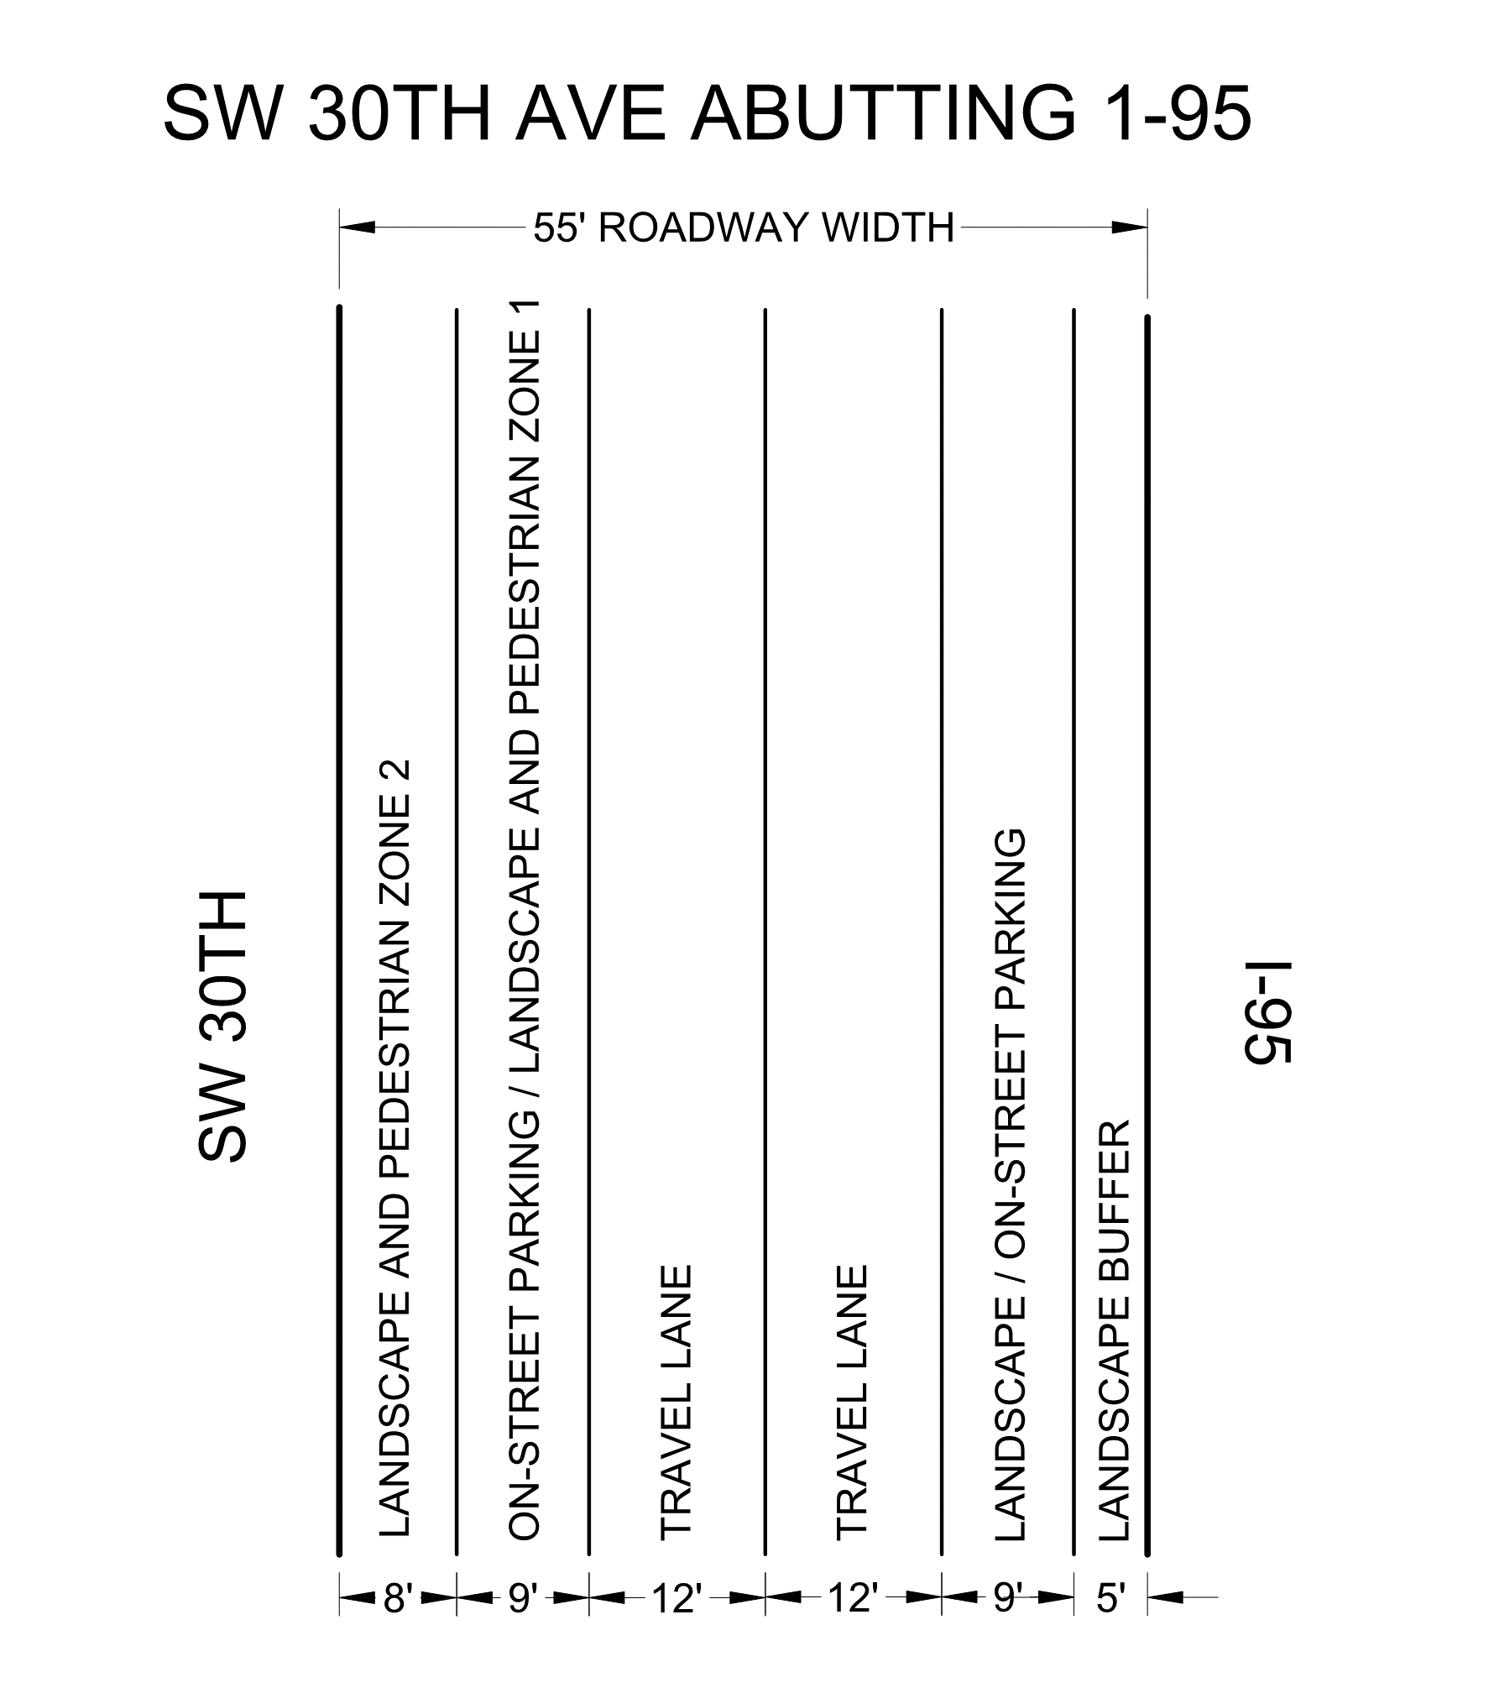

Exhibit G.1.b SW 30th Avenue Road Profile Not Abutting Interstate-95
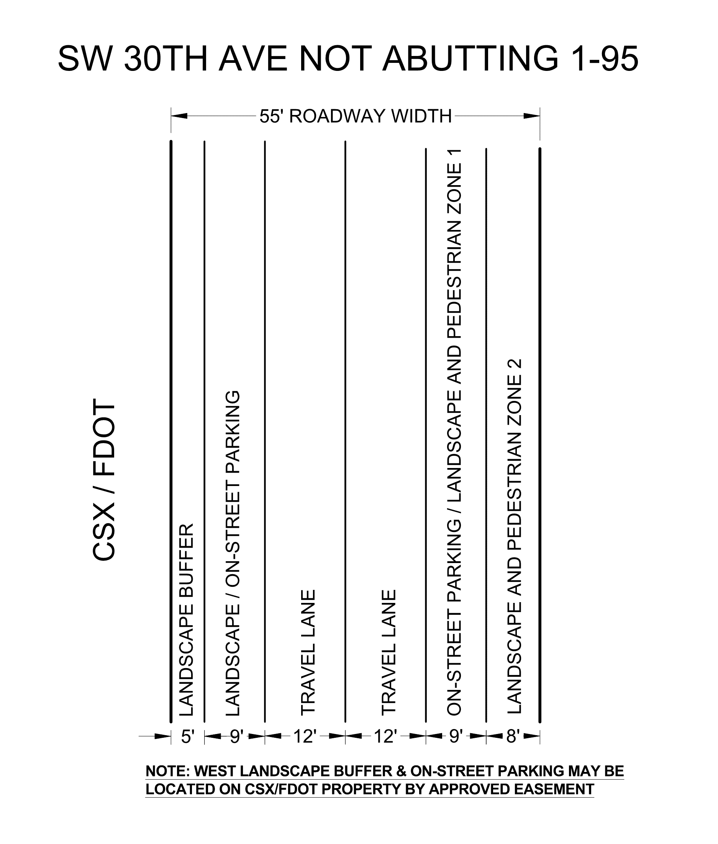
The Town Commission may modify the dimensions and requirements for Landscape/Pedestrian Zones 1 and 2 if determined to be in the best interest of the Town as part of the site plan approval process.
- All remaining setbacks are zero.
H. Off-Street Parking
All developments are required to provide off-street parking in accordance with Sec. 28-301. A development is encouraged seek a parking reduction utilizing approved parking reduction and or demand study methods from Institute of Traffic Engineers (ITE), Urban Land Institute (ULI), American Planning Association (APA) or other organization accepted by the Town Commission.
I. On-Street Parking
On-street parking shall be provided pursuant to the roadway profile in Exhibits G.1.a and G.1.b. It will be the responsibility of the abutting property owner to provide the on-street parking. On-street parking shall be applied to off-street parking requirements for the development.
J. Building over Town Right-of-way
A property owner abutting SW 30th Avenue may enter into a lease agreement with the Town Commission to allow for the ability to develop on the air rights of SW 30th Avenue.
Setback requirements shall be waived for structure within the air rights of SW 30th Avenue.
Other than structural supports for the structure above SW 30th Avenue, the air rights of the first 30 feet from ground level shall remain open to allow for natural light, ventilation, landscape and the service of utilities.
K. Design Standards
The following design standards shall apply to all new developments in the MXE Mixed Use-Entertainment District.
- Landscape and Pedestrian zone 1. Landscape and pedestrian zone 1 is intended to be flexible space to allow a mix of on-street parking, landscape, street furniture including seating, artwork and fountains, and/or expanded pedestrian walkways. The development is encouraged to be creative with the public space immediately fronting the development.
- Landscape and Pedestrian zone 2. Landscape and pedestrian zone 2 is intended to create an expanded pedestrian walkway area with grade level landscape. Planter boxes are prohibited. The development is encouraged to be creative with the public space immediately fronting the development.
- Active uses on ground level. Activation of the ground level is required. The development must adequately provide active uses on the ground level. Activation methods include retail, restaurants, hotel lobbies, residential lobbies, public or private fitness centers or similar uses. 70% of the ground level facade must include clear glass unless waived by Town Commission.
- Upper-level and rooftop decks/Coordination with abutting properties. Upper-level and rooftop decks are encouraged. Upper-level and rooftop decks should include indoor and outdoor commercial uses and be open to the public. Upper-level decks should be coordinated between abutting properties. Upper-level decks must connect when abutting or be connected with skywalks or other creative connections. The Town may require cross access easements to upper-level decks to implement the goals and visions of the Town.
- Vehicle openings. Ground level openings for structured parking and back of house shall be the minimum width practicable. The ground level opening for structured parking and back of house should be shared to avoid conflicts with the active pedestrian areas.
- Back of house/Loading/Refuse. The back of house for all buildings must be screened from view from the public right-of-way (SW 30th Avenue). The back of house should be screened by a wall or active ground floor use. Dumpster and loading areas shall not be seen from the public right-of-way.
- Screening of structured parking. On the ground level, the structured parking (except for the opening) must be screened from the view from the public right-of-way (SW 30th Avenue). Screening of structured parking may include active uses, residential liner units and green walls.
Above the ground level, the structured parking shall be screened along the east and west facades. Screening of structured parking may include decorative screens, liner residential units and liner commercial;/office space.
For properties fronting Pembroke Road and Hallandale Beach Boulevard, structured parking shall be screened from all rights-of-way. Screening of structured parking may include decorative screens, liner residential units and liner commercial;/office space.
- Bicycle parking. Ground level public bicycle parking shall be provided in a location agreed to by the development and the Town. Bicycle parking may be located in the landscape/on-street parking area opposite the development or within landscape and pedestrian zone 1 and zone 2 per exhibits G.1.a and G.1.b or within private property via an easement.
A development shall also provide bicycle parking or bicycle storage for customers, employees and/or residents. The amount of bicycle storage shall be agreed to by the Town and development prior to site plan approval.
Section 3: All ordinances or parts of ordinances in conflict herewith are hereby repealed to the extent of such conflict.
Section 4: It is the intention of the Town Commission of the Town of Pembroke Park that the provisions in this ordinance shall become and be made a part of the Code of Ordinances of the town of Pembroke Park, Florida, and that the Sections of this ordinance may be renumbered, re-lettered, and the word “ordinance” may be changed to “Section”, “Article” or such other word or phrase in order to accomplish such intention.
Section 5: If any phrase, clause, sentence, paragraph or section of this ordinance shall be declared invalid or unconstitutional by the judgment or decree of a court of competent jurisdiction, such invalidity or unconstitutionality shall not affect any of the remaining phrases, clauses, sentences, paragraphs, or sections of this ordinance.
Section 6: This ordinance shall become effective immediately upon its passage and adoption.

THE REMAINDER OF THIS PAGE HAS
BEEN INTENTIONALLY LEFT BLANK

PASSED AND ADOPTED BY THE TOWN COMMISSION OF THE TOWN OF PEMBROKE PARK, FLORIDA, ON THE FIRST READING, THIS ___ DAY OF __________________, 2023.

PASSED ADOPTED BY THE TOWN COMMISSION OF THE TOWN OF PEMBROKE PARK, FLORIDA, ON THE SECOND AND FINAL READING, THIS ___ DAY OF __________________, 2023.

ATTEST:

GEOFFREY JACOBS
Mayor Commissioner

MARLEN D. MARTELL
Town Clerk

Approved as to form and legal sufficiency

__________________________________
Jacob G. Horowitz
Interim Town Attorney

VOTE

GEOFFREY JACOBS

REYNOLD DIEUVEILLE

WILLIAM R. HODGKINS

CODE: Strikethrough indicates deletion. Underline indicates additions.

